**Assignment 2**

# Part B

**Identify True or False:**

|  |  |  |
| --- | --- | --- |
| **Sr.**  **No.** | **Questions** | **True/False** |
| 1 | ls is used to list files and directories in a directory. | **True**  The ls command is used to list files and directories |
| 2 | mv is used to move files and directories. | **True**  The mv command is used to move files and directories from one location to another |
| 3 | cd is used to copy files and directories. | **False**  it is used to change directories |
| 4 | pwd stands for "print working directory" and displays the current directory | **True** |
| 5 | grep is used to search for patterns in files. | **True** |
| 6 | chmod 755 file.txt gives read, write, and execute permissions to the owner, and read and execute permissions to group and others. | **True** |
| 7 | mkdir -p directory1/directory2 creates nested directories, creating directory2 inside directory1 if directory1 does not exist. | **True** |
| 8 | rm -rf file.txt deletes a file forcefully without confirmation. | **True** |

## Identify the Incorrect Commands:

1. **chmodx** is used to change file permissions. 🡪**Incorrect - (chmod)**

**e.g.: chmod 755 file.txt**

1. **cpy** is used to copy files and directories. 🡪 **Incorrect - (cp)**

**e.g.: cp file1.txt file2.txt**

1. **mkfile** is used to create a new file. 🡪**Incorrect – (touch)**

**e.g.: touch file1.txt**

1. **catx** is used to concatenate files. 🡪**Incorrect - (cat)**

**e.g.: cat file1.txt** > **file2.txt**

1. **rn** is used to rename files. 🡪**Incorrect – (mv)**

**e.g**.**: mv file1.txt file.txt**

# Part C

**Question 1:** Write a shell script that prints "Hello, World!" to the terminal.

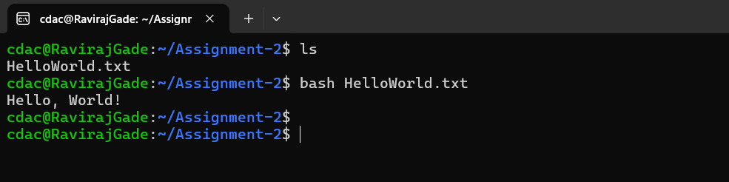

**Question 2:** Declare a variable named "name" and assign the value "CDAC Mumbai" to it. Print the value of the variable.

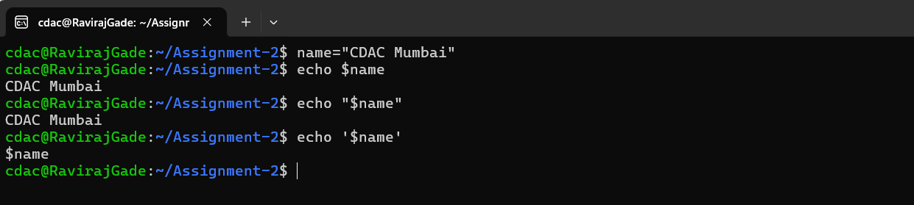

**Question 3:** Write a shell script that takes a number as input from the user and prints it.

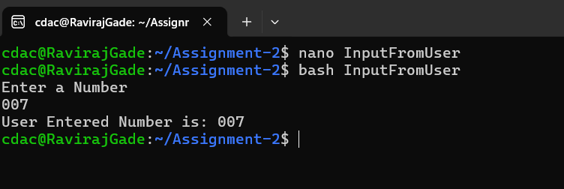

**Question 4:** Write a shell script that performs addition of two numbers (e.g., 5 and 3) and prints the result.

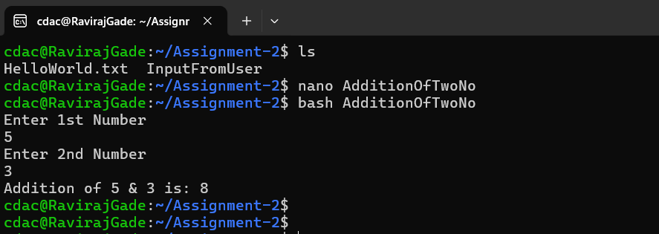

**Question 5:** Write a shell script that takes a number as input and prints "Even" if it is even, otherwise prints "Odd".

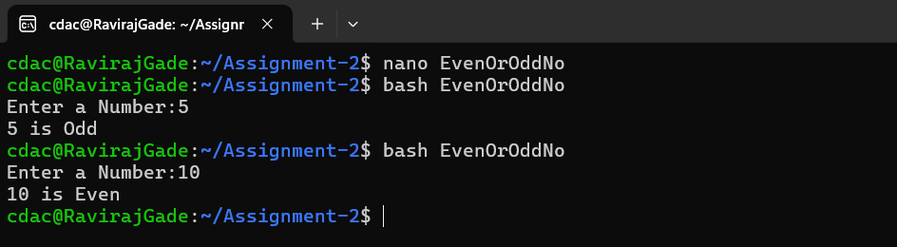

**Question 6:** Write a shell script that uses a for loop to print numbers from 1 to 5.

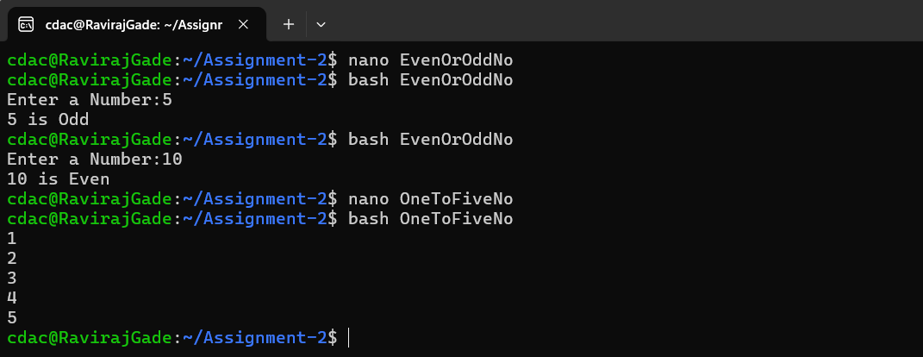

**Question 7:** Write a shell script that uses a while loop to print numbers from 1 to 5.

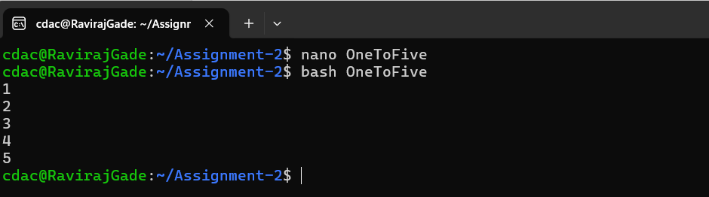

**Question 8:** Write a shell script that checks if a file named "file.txt" exists in the current directory. If it does, print "File exists", otherwise, print "File does not exist".

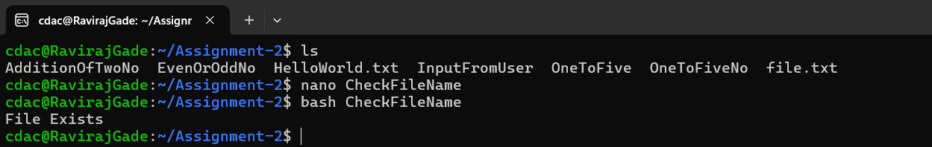

**Question 9:** Write a shell script that uses the if statement to check if a number is greater than 10 and prints a message accordingly.

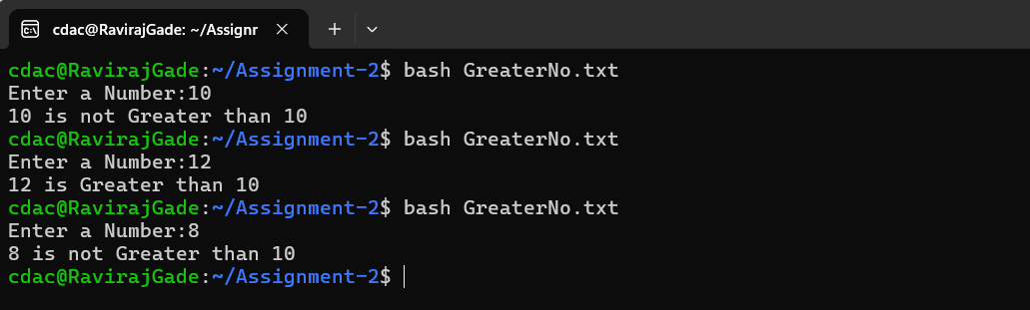

**Question 10:** Write a shell script that uses nested for loops to print a multiplication table for numbers from 1 to 5. The output should be formatted nicely, with each row representing a number and each column representing the multiplication result for that number.

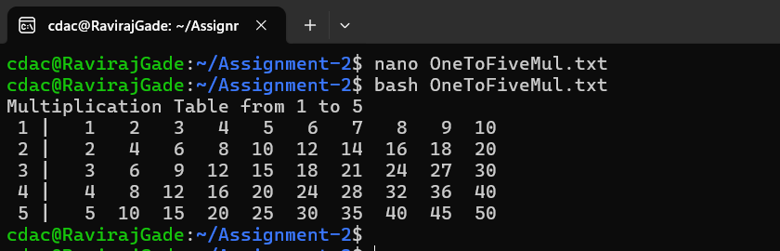

**Question 11:** Write a shell script that uses a while loop to read numbers from the user until the user enters a negative number. For each positive number entered, print its square. Use the **break** statement to exit the loop when a negative number is entered.

